Financial accounting
UNIT-1
- Financial accounting is a branch of accounting which records each financial information and analyse it to determine the financial position of a business. It is a process of recording, summarising, analysing and presenting all financial transactions of a business in the form of financial statements. Financial accounting involves the preparation of various financial statements like income statement, cash flow statement, balance sheet etc. using accounting principles.
- These financial statements are prepared on a routine basis by companies and presented to all its stakeholders. Financial accounting aims at delivering the fair and accurate image of financial affairs of business to all its stakeholders. It is done in accordance with rules provided by GAAP or IFRS. It is an important tool for management in their decision making as they depend on financial reports for decision making and forecasting purposes.
Nature of Financial Accounting
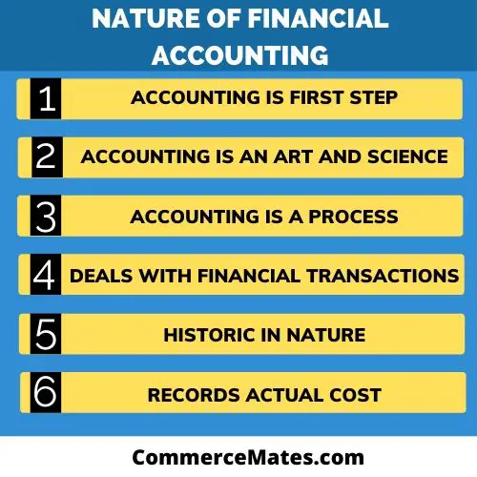

Accounting Is First Step
Accounting is start when a financial transection take place. It records the financial transection after that communicates this information to its users. then the user this information for their decision making.

Accounting Is An Art And Science:
Accounting is an Art and Science as well. Accounting is an art of recording, classifying and summarizing of financial transactions. Accounting is science as well as it requires certain principles (accounting principle).

Accounting Is A Process
Accounting is a process recording of financial transaction, summarizing, analyzing, and reporting to the user of accounting information.

Accounting Deals With Financial Transactions Only
financial accounting is considering only monetary transactions. It does not take into account various non-financial aspects such as market competition, economic conditions, government rules, and regulations, etc.

Historic In Nature
Financial accounting considers only those transactions which are of historic nature. day-to-day activities transactions are recorded and the information is provided after a period of time. All financial decisions of the future are taken on the basis of this past information

Records Actual Cost
Financial accounting records the actual cost of the transaction and does not consider the price fluctuations taking place from time to time. It records the historical cost or the actual cost of the assets or liability.
Functions of Financial Accounting
1. Identification And Recording Of Transactions

Firstly, financial accounting identifies business related financial transactions and records them systematically in chronological order to make easier to understand.

2. Classification And Summarizing The Records
Another function of financial accounting is to classify the transactions according to their nature and summarize them properly. Journal entries and ledger posting are made to classify and summarize transactions.

Analyzing The Data
After classification and summarizing, it analyzes the financial data by preparing trial balance, profit and loss account, balance sheet and other financial statements. Financial statements disclose profit or loss and the financial position of the business for a given period of time.

4. Communication The Result
After analyzing the data and ascertaining the result it communicates financial data and information to the stakeholders such as management, employees, investors, government etc.

5. Facilitates Decision Making
It provides important financial information and statistical data which helps the management to take decisions. It also helps investors or lenders to make financing decisions.

6. Facilitates Future Planning
Management can make future plans and policies on the basis of information gathered by financial accounting.

Objectives of Financial Accounting
- To maintain record of the Business
- Calculation of profit or loss A/c
- Depiction of financial position
- To make information available to various groups

Accounting Principles
Definition: Accounting Principles are the rules and regulations of the accounting language accepted worldwide and are made to make the language understandable for all and ensures the accounting records reliability. Accounting principles should be followed to maintain the resemblance of the records.

Accounting Principles
November 16, 2020 by Anjali J Leave a Comment
Definition: Accounting Principles are the rules and regulations of the accounting language accepted worldwide and are made to make the language understandable for all and ensures the accounting records reliability. Accounting principles should be followed to maintain the resemblance of the records.
So that the records should reveal the same information to everyone using the records to avoid the difficulties and confusions arising due to variation of patterns followed by every individual.
As if rules are not set up, every individual will perform transactions according to their way, and it becomes impossible to compare such records and measure the reliability of the accounting statement.
Thus, it is always advisable to the accountants to follow accounting principles while making the books of accounts of the business.

Content: Accounting Principles
- Generally Accepted Accounting Principles
- Basic Accounting Principles
  - Going Concern Principle
  - Money Measurement Principle
  - PeriodicityPrinciple
  - Duality Principle
  - Revenue Recognition Principle
  - Historical Cost Principle
  - Matching Principle
  - Full Disclosure Principle
- Conclusion

Generally Accepted Accounting Principles
The rules derived from the experience and accepted universally becomes the principles when proved beneficial and such principles are known as “Generally Accepted Accounting Principles” or “GAAP”. It consists of accounting principles along with the methods of exercising such principles.

Basic Accounting Principles
For developing accounting techniques, few rules are required essentially to regulate such techniques, and such rules are the basic accounting principles, navigating the style of recording and reporting of transactions.
The following are some of the basic principles of accounting:
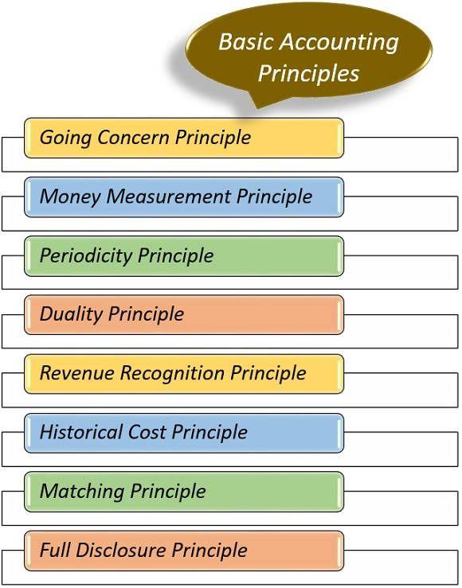
1. Going Concern Principle
Going Concern Principle is based on the assumption that the business will go on irrespective of its owner’s life. It is assumed that the business will not end up in near foreseeable future. This principle plays a role of basic accounting assumption for preparation of the financial statement of the company.
2. Money Measurement Principle
This principle underlines the fact that transactions occurring during the year should have a monetary value to record them in the financial statement. Else, they cannot be recorded such as skill level of the employees and product durability cannot be recorded.
However, these factors have a significant impact on the growth of the financial position, but they are not allowed to be stated in the financial records.
3. Periodicity Principle
This principle is based on the particular time-period concept, i.e., accounting has to be done for a definite period. In general, the profit/loss of the business is computed on the basis of the accounting year, i.e., (From 1st April to 31st March) and computed every year. So, the profit/loss can be compared every year from the previous year.
This will help in recognizing the loops of the business and the reasons behind losses on the basis of which necessary measures can be adopted to avoid such losses in the subsequent years of business.
4. Duality Principle
Duality Principle of accounting is based on the dual facets of the entries made in the records, the example of this principle is the double-entry system of accounting in which every entry has a dual effect, i.e., “Debit” and “Credit”. If any entry gets debited, it will get credited too.
According to this principle, both the parties involved in the transaction will have a dual impact of a particular transaction.
For example:

In case of Cash Transaction
- The dual impact on the selling party would beReceipt of Cash.
- Foregoing of Goods.
Similarly, the dual impact on the purchasing party would be
- Payment of Cash.
- Receipt of Goods.

In Case of Credit Transaction
The dual impact on the selling party would be
- Acquisition of Right to Recover.
- Foregoing of Goods.
Similarly, the dual impact on the purchasing party would be
- Assumption of Obligation to Pay
- Receipt of Goods.
5. Revenue Recognition Principle
Revenue Recognition Principle by its name only defines that it is related to the ‘recognized revenue’ of a company. Here, revenue is a gross inflow of cash from the business activities, done throughout the year by the sale of goods, providing services, etc.
In the case of the agency relationship, the commission amount is considered as revenue income.
However, the revenue gets recognised in the earning year financial statement, whether it has been received or not.
6. Historical Cost Principle
Historical Cost Principle is based on the acquisition cost recorded in the books of accounts, i.e., the cost paid to acquire the asset will be recorded in the books of accounts, and that cost will become a base for further accounting of such asset.
Suppose, no amount has been paid for buying an asset such as a company’s reputation. In that case, however, it is a valuable asset for a company, but it will not get recorded as no amount has been paid to acquire such an asset.
Another example of Historical Cost principle is, suppose the land was purchased for 20,00,000 in 2015, now the value of that land has increased to 50,00,000 in 2020. The land is already recorded in the records for 20,00,000 and will be recorded on the same untill it has been realized. Its value will not increase in the books of accounts.
7. Matching Principle
According to this principle, the expenses and revenue should be matched for the current accounting year, i.e., if the revenue has recognised, cost of goods sold should also be charged in the same accounting period irrespective of the cash being received or not.
Matching principle works on an accrual basis; thus, focuses on the occurrence of the event and not on the receipt of the payment.
For Example, Income of X is 2,00,000 for the accounting year 2019 and has only one expense, i.e., rent of 80,000 annually. But this year, i.e., in 2019 house owner wants a rent in advance for next year, i.e., 2020.
Thus, X paid 1,60,000 in 2019 only, but X will record only 80,000 in 2019 in his books, and the remaining will be recorded in the books of the year 2020 for which it is accounted for.
8. Full Disclosure Principle
Full Disclosure Principle specifies that there should not be any omission while preparing books of accounts. This means 100% income and expenses of a particular accounting year must get recorded in that year accounts only, to show the true and fair value.
If anything gets omitted or not shown it should be mentioned, for example, only 90% sales have been recorded, but it is irrelevant to disclose partial transactions, as it will not fulfil the objectives of preparing accounts if they will not show a correct or exact profit/loss for the year.
If full disclosures were not made in the books of accounts, financial position and performance of the business would not get disclosed fairly.

UNIT – 2

Double Entry System

Introduction
Double-entry accounting refers to the method of bookkeeping which helps a company to maintain its account and keep it balanced which shows the true picture of the finances of the company. Double-entry refers to the use of an accounting asset which is a summation of liabilities and equity. The credits of an account should be equal to keep an equation in perfect balance. Accountants make use of the credit and debit entries so that they can record the transactions of all the accounts. All these credits and debits are shown in the Balance Sheet.

Types of Accounts
All the day to day finally activities are recorded and measured by the accounting and bookkeeping process. An event between two economic entities like between customer and business, or vendor and business-like known as a transaction. To record this event we use accounting and bookkeeping.

A systematic accounting process is a procedure under which the activities of the business are recorded under systematic accounts to keep data sorted and classified under different heads.

To classify all the business accounting entries and transactions there are 7 main types of accounts, which are :
- Assets
- Liabilities
- Equity
- Gains
- Losses
- Expenses
- Revenues

The continuous process of tracking changes in various types of accounts while continued business operations are known as accounting and book-keeping.

Double Account System
The meaning of the double-entry system is generally based on the Dual Aspect Concept. The Dual Aspect Concept is based on the fundamentals of accounting principles. All the transactions related to the business are recorded in the book which is specifically based on the principle of accounting.
According to the Dual Aspect Concept, all business transactions have a two-way or dual effect. This tells us that the business transaction of the particular entity has a minimum of two accounts which are recorded in the books. This principle is known as the double-entry concept or system.

Single Entry System Meaning
A single entry system refers to the form of bookkeeping where each company maintains its financial transactions in a single-entry log. The single-entry system does not involve any formal training and is usually based on new businesses because of its cost-effectiveness and simplicity.

The single entry system records the description, date, transaction value, expenses and income, and lastly balance. This is maintained while doing every transaction for the company. It also includes income tax depending on the type of business.

Who Uses A Single Entry System?
Small businesses use a single entry system. They record bare essentials only and the criteria for a company to be rendered fit for such a system are:
- Having few employees.
- Ones that use transactions based on cash
- Very fewer transactions
- Do not have an installment plan
- Have fewer physical assets like equipment, buildings, and vehicles

Single Entry System and Double Entry System
There are a few significant differences between the single entry system and the double-entry system. These are:
- The single entry system tells about debtors, cash, and creditors’ cash balance only whereas the double-entry system tells about all the business entities
- The records in the single entry system are only related to business. The records in the double-entry system affect all the transactions in the business.
- The single entry system has an incomplete way of maintaining transactions. In a double-entry system, it is difficult to carry out fraud.
- Errors cannot be easily found in a single entry system while errors can be easily detected in a double-entry system.
- The single entry system is not accepted by the tax department but the double-entry system is accepted by the taxation department.

